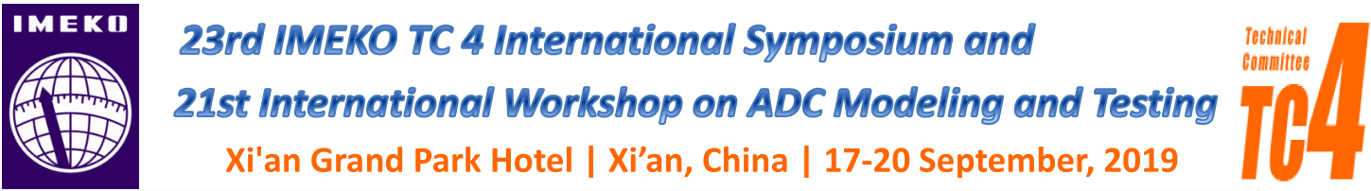

23rd IMEKO TC 4 International Symposium and
21st International Workshop on ADC Modeling and Testing

Xi’an, China, 17-20 September 2019

COPYRIGHT FORM

Upload this form IN PDF FORMAT signed to IMEKO website:
https://imeko2019.aconf.org/index.html My Info>Submission> upload copyrights file

Paper ID:
Paper Title:
Author’s Name:
Affiliation:
Mailing address:
Telephone/Fax/Email

To the Symposium Secretariat:

Declaration
I agree the manuscript of my paper presented at 23rd IMEKO TC 4 International Symposium and 21st International Workshop on ADC Modeling and Testing above to be published in the following electronic versions: congress web page, IMEKO web page, and in digital media distributed to congress attendees.
The owner of the copyright is the International Measurement Confederation.
I agree that no honorarium is due.
I confirm that the contents of my paper have not been, or will not be submitted elsewhere for publication in substantially the same form without the written permission of IMEKO.
I also give my permission to IMEKO to use my address and other contact information in the Scientific Contact Service and to forward my address to Institutes and Companies wishing to contact me as an expert. My expertise area is indicated by the keywords I have given in my papers and articles.

Date: xx/xx/2019

Signature:

