Template for Full Paper Informative and Concise Paper Title Here

Ciren Wu a,*, John Fakename b

a Department of Environmental Science, World Class University, City, Province 123456, Country

b Animal Science and Technology Institute, City, State 54321, Country

* Corresponding author. Email: xyz@nowhere.ss

Abstract

This template is designed to assist editing and printing a high-quality proceedings book. It will also be helpful for preparing papers for the symposium. Please follow the format requirements outlined in the template and use the built-in pre-defined styles. If you have any questions about this template, please contact Dr. Jiqin (J.Q.) Ni (email: [jiqin@purdue.edu](mailto:jiqin@purdue.edu)).

Please use the full term rather than acronyms or chemical formulas in the title and abstract. Write a concise and factual abstract in this section. Limit the length of the abstract to maximum of 250 words. Instructions about how to write abstracts are provided by many reputable scientific journals, for example: “The abstract should state briefly the purpose of the research, the principal results, and major conclusions. An abstract is often presented separately from the article, so it must be able to stand alone. For this reason, references should be avoided, but if essential, then cite the author(s) and year(s). Also, non-standard or uncommon abbreviations should be avoided, but if essential they must be defined at their first mention in the abstract itself”. (<http://www.elsevier.com/journals/environmental-pollution/0269-7491/guide-for-authors>).

**Keywords:** Leave the word “Keywords:”, type 5 to 6 keywords or key phrases, and separate them with commas here. You can list both specific and general terms that will aid in searches. Avoid repeating the nouns or phrases in the paper title because almost all the nouns in the title of a scientific paper are keywords.

## 1. Introduction

The required length of a research paper is 6–8 pages and a review paper is 6–10 pages for this symposium proceedings. Provide an adequate background in this Introduction section to assist readers understand the significance of the research presented in your paper but avoid a detailed literature survey or a summary of the results. State also the objectives of the work in this section.

## 2. Materials and Methods

Provide sufficient details of the materials and methods to allow your work to be reproduced.

### 2.1. Paper and text areas

This template uses A4 size paper (21 cm × 29.7 cm) because the proceedings book will be printed in China. The text area of the template is 12.3 cm × 19 cm to fit in the printed proceedings book of 15.2 cm × 22.7 cm paper size without reduction.

### 2.2. Font and headings

The basic font of this template is 9 pt Times New Roman. Use the “Body Text” style, which has an indent of 0.5 cm, for the paper text (Figure 1). Use the three levels of numbered Headings built in the template to design your paper structure. Please limit the heading levels to three.

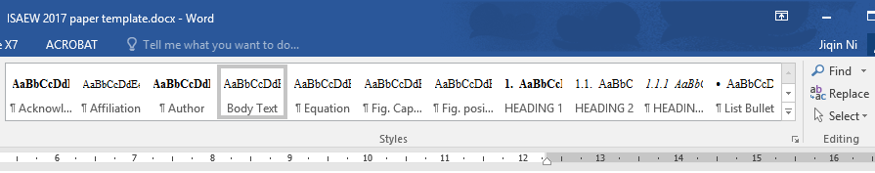

Figure 1. Select and use the built-in styles in this template.

### 2.3. Equations

Do NOT use the MS Word in the tool bar “Insert” – “Equation” (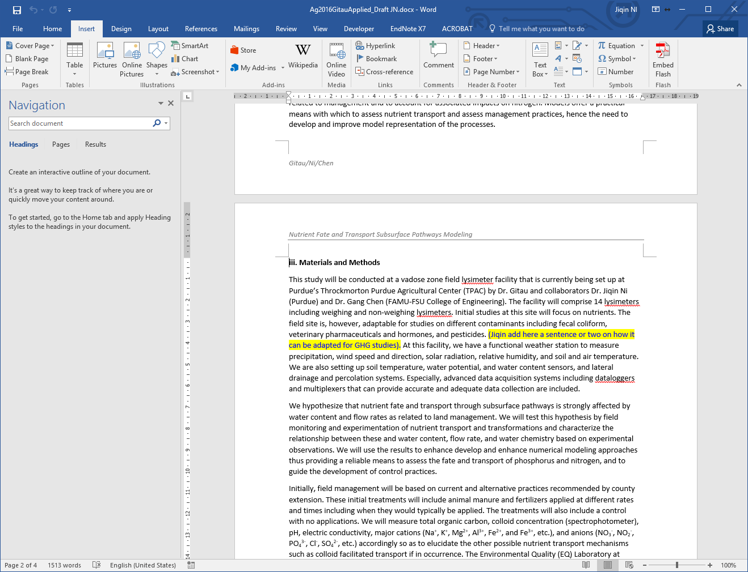) to compose equations if possible.

Instead, use Microsoft Equation 3.0 (a built-in tool in MS Word) or MathType (a software application created by Design Science [www.dessci.com](http://www.dessci.com)) to compose your equations. To insert a MS Equation 3.0 or Math Type, go to menu “Insert” – “Text” group, select “Object” then “Object…”, then select “Microsoft Equation 3.0” or “Math Type”.

An example equation using 9 pt size font is shown here in Eq. (1).

 (1)

where *E* is aerial pollutant emission rate, mass time-1; *Q* is air exchange rate, volume time-1; *C*1 and *C*2 are aerial pollutant concentrations at the inlet and outlet of the air exchange space, respectively, mass volumn-1. (Use the no-indent “Normal” style for this “where…” sentence and with the “w” in lower case because this sentence is part of the equation).

More explanation about your equation can start here using the “Body Text” style. If your MS Word has Math Type installed, you can simply copy Eq. (1) in this template, paste it where you need, double-click the equation, and edit it to your equation.

Use the “Equation” style in this template and place one tab before and one tab after the equation (Figure 2).

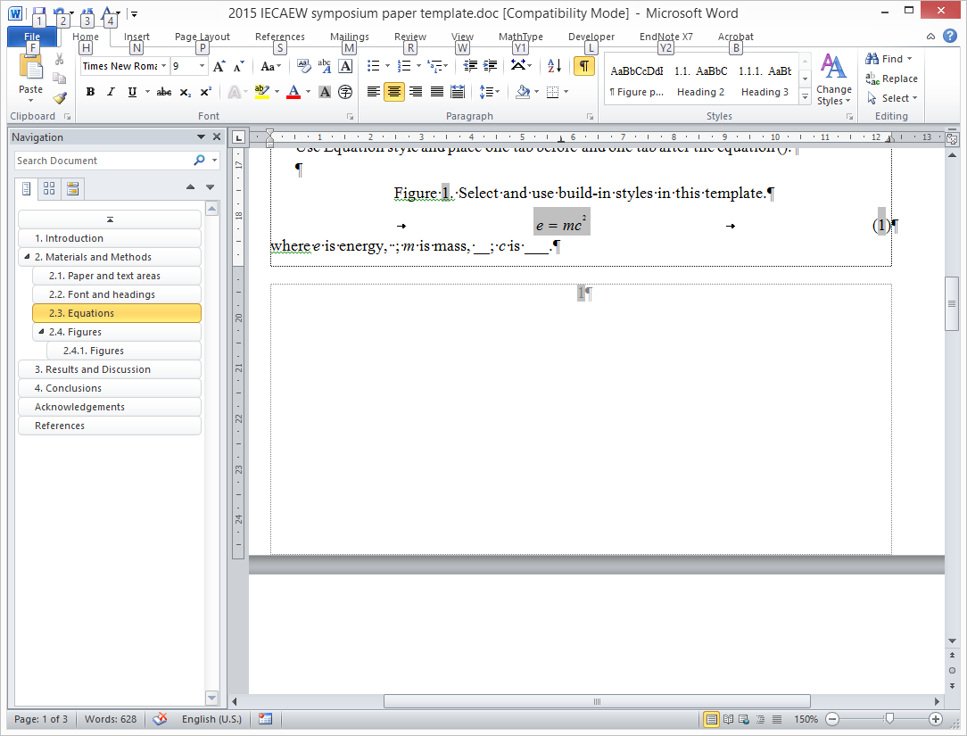

Figure 2. An equation using the “Equation” style with one tab before and one tab after the equation.

To show or hide the tabs and spaces, etc., click the paragraph mark “¶” in Home – Paragraph group.

## 3. Results and Discussion

Write in this section what you have obtained from your work and how you interpret them. This section can also be separated into two sections: 3. Results and 4. Discussion.

### 3.1. Figures

Use the “Fig. Position” style for the figure and the “Fig. Caption” style for the figure caption. All figures should be formatted consistently and highly legible. Please read the following suggestions to create high quality printing of figures for your paper.

* Design or resize your figures so that the text in the figures will appear approximately 9 pt Times New Roman font size, which is the size of Body Text in the paper, or no smaller than 7 pt..
* Compose a clear and descriptive figure caption, which should allow readers to understand who, what, where, and when about the figure as much as possible without requiring the readers to hunt for answers of these questions in the text.
* Format the Layout of figures using “In line with Text.” Do not have floating figures unless it is needed for typesetting purpose.
* Color will be shown in the e-version only, but not in the printed Proceedings. Please test your color figures by printing them in paper in black and white and make sure that they are legible.
* Figures will not be reduced in printing. Limit their maximum width to 12.3 cm.

#### 3.1.1. Photos and scanned images

For digital photos, use 300-dpi resolution. If you use a scan, please select 600 dpi for line art and 300 dpi for grayscale and photos.

#### 3.1.2. Drawings and charts

If you copy a drawing or chart from Excel, Power Point, or other software, paste it in this Word template file using “Paste” – “Paste Special…”, then select “Picture (Enhanced Metafile)” to keep the maximum clarity and make it easily resizable (Figure 3).



Figure 3. An example of a chart from MS Excel pasted here using “Paste Special” – “Picture (Enhanced Metafile)”.

### 3.2. Tables

Use the “Table Caption” style for the caption and “Table Contents” style for the table.

Avoid tables with too many columns. A table should usually be designed to have more rows than columns.

Compose a clear and descriptive table caption the same way as a figure caption (See Section 3.1).

Do not paste the table as a picture. Leave the table editable for editors to reformat when it is necessary (Table 1).

Table 1. An example table: registration fees of 2021 ISAEW, Chongqing, China.

|  |  |  |  |
| --- | --- | --- | --- |
| Attendee category | Early registration  by June 10, 2021 | Regular registration  by August 31, 2021 | On-site  registration |
| Other countries – Regular | N/A* | N/A* | $400 |
| China – Regular | ¥1800 | ¥2000 | ¥2200 |
| Other countries – Students | N/A* | N/A* | $200 |
| China – Students | ¥900 | ¥1000 | ¥1100 |

* Currently not available but will be updated once the service becomes available.

### 3.3. In-text citations

The author-year style should be used for in-text reference citations.

For single author references, use the author’s name (without initials, unless there is ambiguity) and the year of publication.

More than one reference from the same author(s) in the same year must be identified by the letters “a”, “b”, “c”, etc., placed after the year of publication, e.g., (Smith, 2014a, 2014b, 2018).

For two-author references, use both authors’ names and the year of publication, e.g., (Wang and Jones, 2013).

For references with three or more authors, use the first author’s name followed by “et al.,” and the year of publication, e.g., (James et al., 2016).

Citations may be made parenthetically or directly, e.g., “…as already demonstrated in several publications (Smith, 2014a, 2014b, 2018; Wang and Jones, 2019; James et al., 2016). Recently, Liu et al. (2020) have also shown that...”.

### 3.4. English spelling and language editing

As an international symposium, you are free to select either American English or British English spelling in your paper, but do not use mixed spelling in the same paper.

Ensure that your work is written in correct scientific English before submission. Professional language editing services are available, for example:

<http://www.aje.com/us/>; <http://webshop.elsevier.com/languageservices/languageediting/>

However, these services are provided by outside vendors and are not endorsed by the ISAEW.

### 3.5. Units and numbers

The SI (metric) units and SI derived units should be used. More information about these units can be found in <http://physics.nist.gov/cuu/Units/units.html>.

If other units (e.g., U.S. Customary units) are necessary, they should be provided in parentheses.

Express the SI derived units or other units in exponent form with spaces between the elements of the derived unit, e.g., 1.5 kg d-1 and 34.5 mg m-2 d-1.

Use a comma for five-digit and larger numbers, e.g., 4530 kg; 10,000 kg (not 10000 kg).

### 3.6. Web Links

To break the line of long web links without breaking the links, position the cursor where you want to break, e.g., after each slash “/” in the URL. Click the “Insert” tab, click “Symbol” in the “Symbols” group, and select “More Symbols”. In the Symbol window (Figure 4), click the “Special Characters” tab, select “No-Width Optional Break”, click Insert.

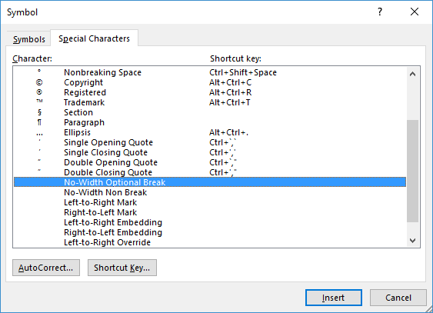

Figure 4. Insert a “No-Width Optional Break” to break a long web link line without breaking the link.

## 4. Conclusions

The “Conclusions” section is for you to present your research findings. Do not write what you did or how you did in the research, such as “The nursery pig health as affected by high ammonia concentrations was studied using two advanced respiratory chambers”, because these are your materials and methods used in the research, not conclusions that you drew from the research.

Occasionally, some authors like to give the reader a brief overview of the study, similar to an abstract, in this section. If this is your preference, then change the section heading to “Summary”, but do not simply copy the sentences from the “Abstract”. If the length of presenting your research findings in the Summary is close to half of the total length of this section, the heading “Summary and Conclusions” can be used.

Acknowledgements

Acknowledgements, if any, can be placed here.

References

Please do not exceed 30 cited references for a research paper. For a review paper, this number can be 60. Make sure that all the cited references are listed here, and all the listed references are cited in the paper. Using of publication DOI is encouraged.

For EndNote users, an EndNote style file for the ISAEW 2017 papers will be sent to you by contacting Dr. Jiqin (J.Q.) Ni (Email: [jiqin@purdue.edu](mailto:jiqin@purdue.edu)).

Select the “RefListing” in the built-in styles to format the reference list. The references should be arranged alphabetically by the last name of the first author or, if the author is not available, by the title, then sorted chronologically.

The following examples of reference arrangements should be used: Forbes (2006) for technical reports, Huo (2011) for theses and dissertations, IRCAEW (2011) for internet resources, Janni et al. (2005) for conference proceedings papers, Ni and Heber (2008) for book sections, Waldau (2010) for books, and Xin et al. (2011) for journal articles. The list of the references should be sorted alphabetically.

Forbes, E.G.A., D.L. Easson, V.B. Woods, and Z. McKervey, 2006. An evaluation of manure treatment systems designed to improve nutrient management - A report to the expert group on alternative use of manures. Occasional publication No. 5. Global Research Unit, AFBI Hillsborough, Down, Northern Ireland. May.

Huo, C., 2011. Analysis and Assessment of Nutrients and Physiological Activity Components in Anaerobic Digestion Effluent of Livestock Farm. MS Thesis, College of Engineering, China Agricultural University, Beijing, China.

IRCAEW, 2011. Constitution of International Research Center for Animal Environment and Welfare. [www.ircaew.org/Introduction/2013-08-06/1450.html](http://www.ircaew.org/Introduction/2013-08-06/1450.html). Accessed March 1, 2015.

Janni, K.A., L.D. Jacobson, R.E. Nicolai, B. Hetchler, and V.J. Johnson, 2005. Airflow reduction of large belt-driven exhaust ventilation fans with shutters and loose belts. In *Seventh International Livestock Environment Symposium*. Beijing, China, May 18-20. St. Joseph, Mich.: ASAE. Eds., T. Brown-Brandl and R. Maghirang. 245-251.

Ni, J.-Q., A.J. Heber, 2008. Chapter four: Sampling and measurement of ammonia at animal facilities. Advances in Agronomy. 98, 201-269. <http://doi.org/10.1016/S0065-2113(08)00204-6>.

Waldau, P., 2010. *Animal Rights: What Everyone Needs to Know*. Oxford: Oxford University Press. 220 p.

Xin, H., R.S. Gates, A.R. Green, F.M. Mitloehner, P.A. Moore, C.M. Wathes, 2011. Environmental impacts and sustainability of egg production systems. Poultry Science. 90 (1), 263-277. <http://doi.org/‌10.3382/ps.2010-00877>.

Disclaimer: It is authors’ responsibility to obtain written permissions to use copyrighted materials (e.g., figure, photo, table) and not to commit plagiarism and self-plagiarism when writing with this template.

Copyright © 2015–2021 Jiqin Ni

This template was created for the International Research Center for Animal Environment and Welfare (IRCAEW). Written permission is required for other organizations to use this template. Contact: Dr. Jiqin (J.Q.) Ni (Email: [jiqin@purdue.edu](mailto:jiqin@purdue.edu)).

This template was last updated on May 9, 2023.