Template for Extended Abstract Informative and Concise Title Here

Ciren Wu a,*, John Fakename b

a Department of Environmental Science, World Class University, City, Province 123456, Country

b Animal Science and Technology Institute, City, State 54321, Country

* Corresponding author. Email: xyz@nowhere.ss

## 1. Introduction

The required length of an extended abstract is **2–4 pages**. Provide a brief background in this Introduction section to assist readers understand the significance of the research. State also the objectives of the work in this section.

## 2. Materials and Methods

Provide sufficient details of the materials and methods, or with sufficient references.

### 2.1. Paper and text areas

This template uses A4 size paper (21 cm × 29.7 cm).

### 2.2. Font and headings

The basic font of this template is 9 pt Times New Roman. Use the “Body Text” style, which has an indent of 0.5 cm, for the paper text (Figure 1). Use the three levels of numbered Headings built in the template to design your paper structure. Please limit the heading levels to three.

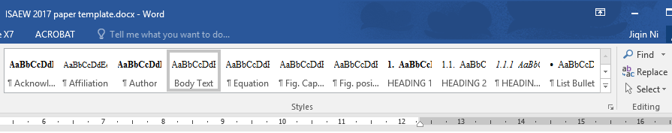

Figure 1. Select and use the built-in styles in this template.

## 3. Results and Discussion

Write in this section what you have obtained from your work and how you interpret them.

### 3.1. Figures

Use the “Fig. Position” style for the figure and the “Fig. Caption” style for the figure caption. All figures should be formatted consistently and highly legible. Please read the following suggestions to create high quality figures.

* Design or resize your figures so that the text in the figures will appear approximately 9 pt Times New Roman font size, which is the size of Body Text in the paper, or no smaller than 7 pt.
* Compose a clear and descriptive figure caption, which should allow readers to understand who, what, where, and when about the figure as much as possible without requiring the readers to hunt for answers of these questions in the text.
* Format the Layout of figures using “In line with Text.” Do not have floating figures unless it is needed for typesetting purpose.

#### 3.1.1. Photos and scanned images

For digital photos, use 300-dpi resolution. If you use a scan, please select 600 dpi for line art and 300 dpi for grayscale and photos.

#### 3.1.2. Drawings and charts

If you copy a drawing or chart from Excel, Power Point, or other software, paste it in this Word template file using “Paste” – “Paste Special…”, then select “Picture (Enhanced Metafile)” to keep the maximum clarity and make it easily resizable (Figure 3).



Figure 3. An example of a chart from MS Excel pasted here using “Paste Special” – “Picture (Enhanced Metafile)”.

### 3.2. Tables

Use the “Table Caption” style for the caption and “Table Contents” style for the table.

Avoid tables with too many columns. A table should usually be designed to have more rows than columns.

Compose a clear and descriptive table caption the same way as a figure caption (See Section 3.1).

Do not paste the table as a picture. Leave the table editable for editors to reformat when it is necessary (Table 1).

Table 1. An example table: registration fees of 2021 ISAEW, Chongqing, China.

|  |  |  |  |
| --- | --- | --- | --- |
| Attendee category | Early registration  by June 10, 2021 | Regular registration  by August 31, 2021 | On-site  registration |
| Other countries – Regular | N/A* | N/A* | $400 |
| China – Regular | ¥1800 | ¥2000 | ¥2200 |
| Other countries – Students | N/A* | N/A* | $200 |
| China – Students | ¥900 | ¥1000 | ¥1100 |

* Currently not available but will be updated once the service becomes available.

### 3.3. In-text citations

The author-year style should be used for in-text reference citations.

For single author references, use the author’s name (without initials, unless there is ambiguity) and the year of publication.

More than one reference from the same author(s) in the same year must be identified by the letters “a”, “b”, “c”, etc., placed after the year of publication, e.g., (Smith, 2014a, 2014b, 2018).

For two-author references, use both authors’ names and the year of publication, e.g., (Wang and Jones, 2013).

For references with three or more authors, use the first author’s name followed by “et al.,” and the year of publication, e.g., (James et al., 2016).

### 3.4. English spelling and language editing

As an international symposium, you are free to select either American English or British English spelling in your paper, but do not use mixed spelling in the same paper.

Ensure that your work is written in correct scientific English before submission. Professional language editing services are available, for example:

<http://www.aje.com/us/>; <http://webshop.elsevier.com/languageservices/languageediting/>

However, these services are provided by outside vendors and are not endorsed by the ISAEW.

### 3.5. Units and numbers

The SI (metric) units and SI derived units should be used. More information about these units can be found in <http://physics.nist.gov/cuu/Units/units.html>.

If other units (e.g., U.S. Customary units) are necessary, they should be provided in parentheses.

Express the SI derived units or other units in exponent form with spaces between the elements of the derived unit, e.g., 1.5 kg d-1 and 34.5 mg m-2 d-1.

Use a comma for five-digit and larger numbers, e.g., 4530 kg; 10,000 kg (not 10000 kg).

### 3.6. Web Links

To break the line of long web links without breaking the links, position the cursor where you want to break, e.g., after each slash “/” in the URL. Click the “Insert” tab, click “Symbol” in the “Symbols” group, and select “More Symbols”. In the Symbol window (Figure 4), click the “Special Characters” tab, select “No-Width Optional Break”, click Insert.

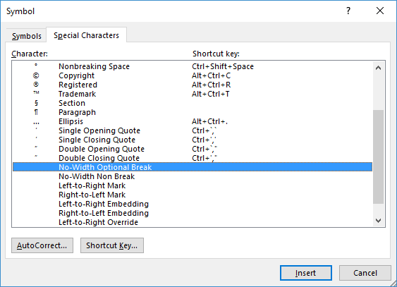

Figure 4. Insert a “No-Width Optional Break” to break a long web link line without breaking the link.

## 4. Conclusions

The “Conclusions” section is for you to present your research findings.

Acknowledgements

Acknowledgements, if any, can be placed here.

References

Please do not exceed 5 cited references for an extended abstract.