The 9th International Conference on Virtual Reality and Visualization（ICVRV 2019）
Invitation

http://www.icvrv.org
Nov. 19th, 2019

SPONSORS
China Computer Federation, CCF
IEEE
Organizers
State Key Laboratory of Virtual Reality Technology and System, BUAA
Virtual Reality and Visualization Technology, CCF (CCF TCVRV）
Hong Kong University
SUPPORTERS
China Society of Image and Graphing
China Simulation Federation

The 9th International Conference on Virtual Reality and Visualization (ICVRV 2019) was planed and announced to be held in Hong Kong University, Hong Kong, China, from November 21st to 22nd, 2019. As turbulence become more and more serious while the conference day is coming, the committee decides emergently to move the venue to SHENZHEN UNIVERSITY TOWN CONFERENCE CENTER, Shenzhen, China.
ICVRV 2019 seeks original, high-quality papers in all areas related to Virtual Reality (VR), Augmented Reality (AR) and Mixed Reality (MR). We invite submissions of new ideas, and encourage all forms of research creativity and originality. We are interested in theoretical and technological innovations, novel applications, practice and experience analyses, and we hope to establish standards in this field and stimulate future trends.
- Paper publishing and best paper award
All accepted ICVRV papers will appear in the Proceedings of ICVRV 2019 and will be submitted for inclusion to the IEEE Xplore Digital Library as well as other Abstracting and Indexing (A&I) databases. Some selected papers will be recommended to publish at the SCI-indexed Journals.
All accepted submissions MUST be registered and presented orally at ICVRV 2019.
From all accepted and presented papers, an International jury will select the best papers. The best paper will receive the Best Paper Award, including a cash prize, presented at ICVRV 2019.
- Registration
Registration Category
 | On-line  (Until Nov. 22nd) |  | On-site  (Nov.21st-Nov. 24th)
Regular | USD 500 | RMB 3500 | USD 550 | RMB 3900
IEEE/CCF/CSF/CSIG Member | USD 400 | RMB 2800 | USD 450 | RMB 3200
Student | USD 300 | RMB 2100 | USD 350 | RMB 2500

Please register on conference website: http://www.icvrv.org/register.html

All types of ICVRV registrations include a complementary registration for the ChinaVR conference, held in Shenzhen (40 minutes by train) from Nov. 21-24.
- Brief Program
Date |  | Program
Oct. 21st |  | Registration
Oct. 22nd |  | IVRTC 2019 and Registration
Oct. 23th | Morning | Open ceremony & Invited Speech
 | Afternoon | Technical Sessions
Oct. 24th | Morning | Invited Speech
 | Afternoon | Technical Sessions

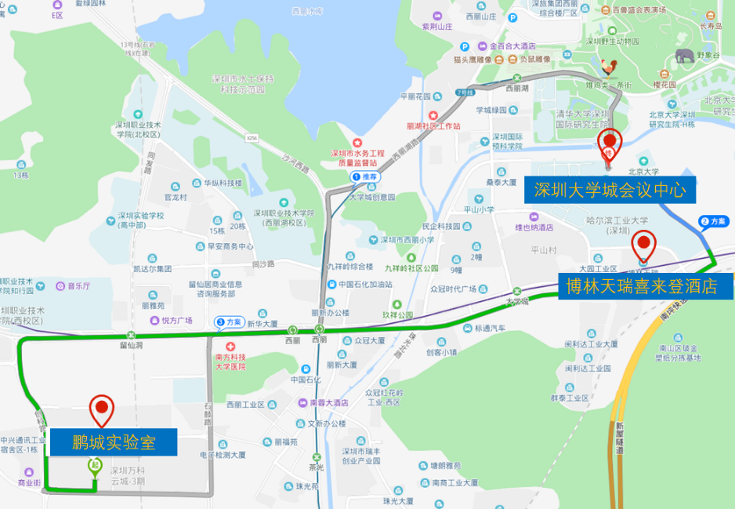
- Venue

SHENZHEN UNIVERSITY TOWN CONFERENCE CENTER
- Contact
Website: http://www.icvrv.org/
Registration: Prof. Jia Jinyuan, reg2019@icvrv.org
Publication: Prof. Jian Zhao, publication2019@icvrv.org
Conference affairs: Mr. Wang Shaoxiong, info@icvrv.org,
Financial affairs: Mrs. Joey Zhou, +86 27 8887 5258, joey@aconf.org

Virtual Reality and Visualization Technology, CCF (CCF TCVRV）
中国计算机学会虚拟现实与可视化技术专业委员会

Nov. 19th, 2019

